1.

a) Regular expression: /123/g. Matches: 12.

b) Regular expression: /.*[0-9].*/g. Matches: 30.

c) Regular expression: /[aeiou]/g. Matches: 169.

d) Regular expression:/[aeiou].[aeiou]/g. Matches: 23.

2.

|  |  |  |  |
| --- | --- | --- | --- |
|  | a | b | c |
| →q0 | q1 | - | - |
| q1 | q2 | q1 | - |
| q2 | - | q2 | q3 |
| *q3 | - | - | - |

a) ∑ = {a, b, c}

b) ∑ = {a, b}

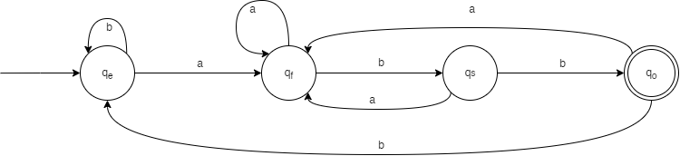

3.

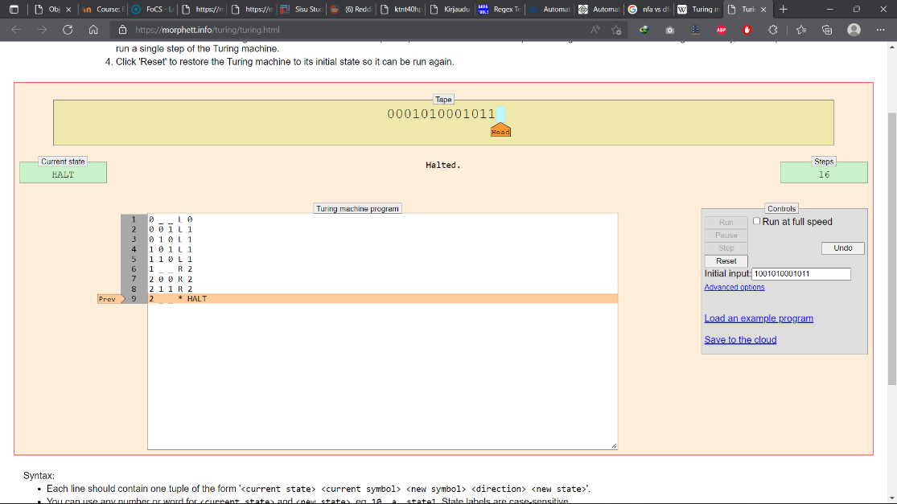a) i) 7 steps

0 _ _ L 0

0 0 1 L 1

0 1 0 L 1

1 0 1 L 1

1 1 0 L 1

1 _ _ R 2

2 0 0 R 2

2 1 1 R 2

2 _ _ * HALT

ii) 9 steps

iii) 16 steps

b) The program does calculations based on the arithmetic sequence an = 5 + (8n−8). The nearest value belonging to the sequence that has the same number of digits as the input will be returned.

4.

a) **b**1010b → **b**b1010b → b**b**1010b

**b**0110b → **b**b0110b → b**b**0110b

**b**bbbbb → **b**bbbbbb → b**b**bbbbb

5.

The machine will halt at stage 4 without any additional message if the input satisfies the language requirement. Otherwise, the machine will halt at other stages and displays an error message.

Input aaabbbaabb (satisfied requirement):

0 X X R 0

0 _ _ * 4

0 a X R 1

0 b X R 2

1 a a R 1

1 X X R 1

1 b X L 3

2 b b R 2

2 X X R 2

2 a X L 3

3 X X L 3

3 a a L 3

3 _ _ R 0

4 _ _ * HALT

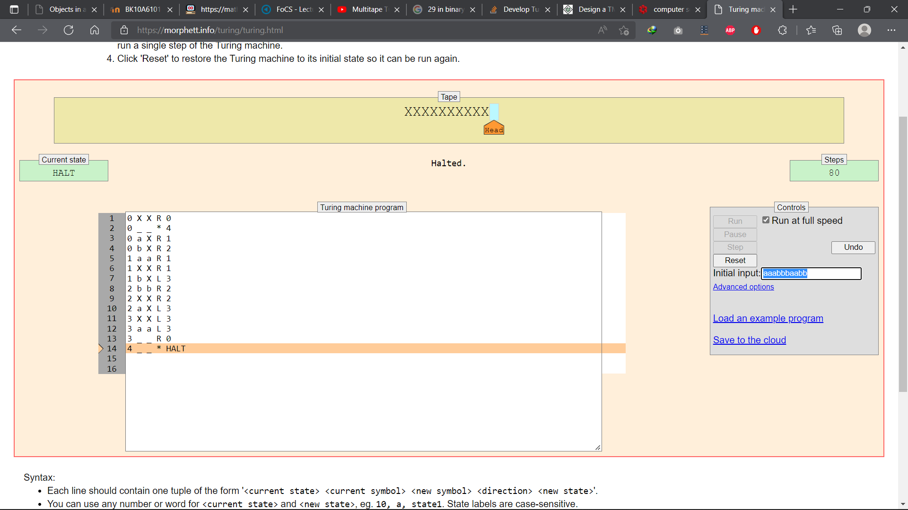

Input abbaabb (not satisfied requirement):

